**Technologies behind SOA**

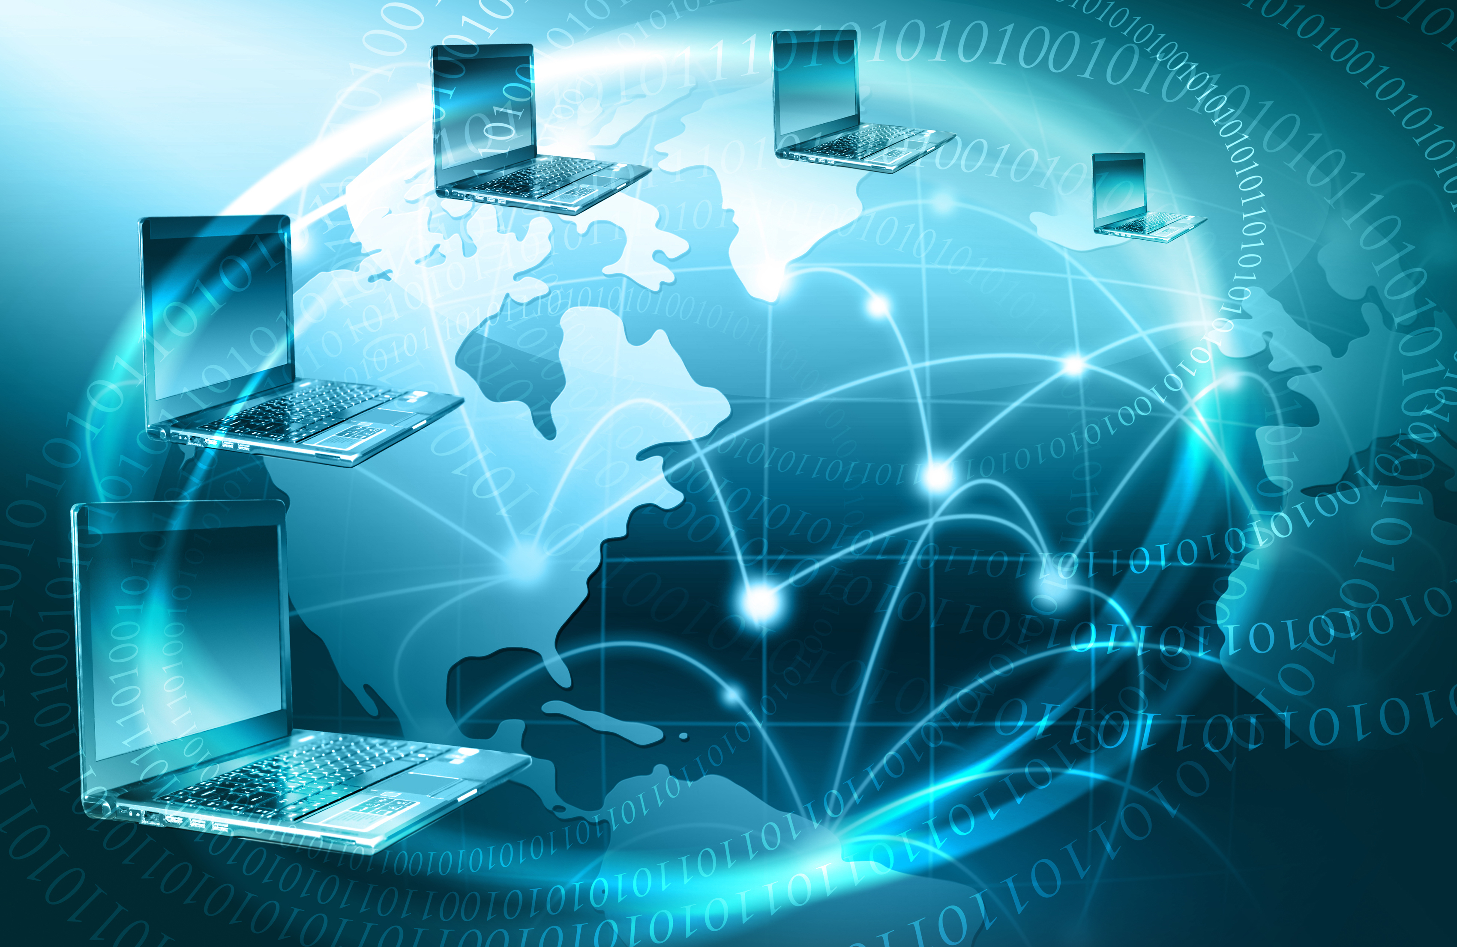

**Rameshkartik.RS**

**Table of Contents**

Introduction 2

Technologies behind SOA 3

UDDI 4

Summary 6

**WHAT’s IN THIS ARTicle?**

* Technologies Behind SOA [WSDL,UDDI]
* Summary

# Introduction

Any architectural approach will not get succeed until the right technology been invented with the right benefit to follow and adapt. There are numerous technologies in the world for the SOA. In this article you will see few technologies like WSDL, UDDI.

# Technologies behind SOA

SOA is intended to create distributed and cross-platform applications, so the supporting technologies and protocols need to be industry standards, the followings are most used standards in the SOA world

**WS -* Protocols**

SOAP is only a specification how the functional data in the body and the technical data in the headers are formatted. It does not define the meaning of the header. These set of protocols describe how the plumbing needs to exchange messages in a secure, transactional and reliable way by using the headers in the SOAP message.

**WSDL**

WSDL is a XML –formatted definition of the contract. It actually describes the client –server interface, including the function names, parameter name, and their types and the types of return values. It can be used by non - .net development environments to contact the services. WSDL file can be shown in a browser when browsing a dedicated URL on which the WCF services exposes metadata. The WSDL file describing a service is stored on a server, perhaps in the registry or the These application servers. It will be read by the client using a simple HTTP GET exchange.

WSDL Document has the three parts

* Definition
* Operations
* Service Bindings

Definition - Definitions are about data types as well as messages. It can be expressed in XML

Service Bindings - It ties the protocol and the message format to a specific port.   
Binding are typically created using SOAP

<service name="StockService" interface="tns:AvailabltyCheckInterface">

<endpoint name="StockServiceRestEndpoint"

binding="tns:AvailabltyCheckInterfaceHttpBinding"

address="http://soaexample.org/rest/"/>

<endpoint name="StockServiceSoapEndpoint"

binding="tns:AvailabltyCheckInterfaceSoapBinding"

address="http://soaexample.org/soap/"/>

</service>

# UDDI

Hope you are familiar how you can describe your services, Now we will see How you can discover the services and consume them? This you can achieve it by UDDI.

UDDI – (Universal Description, Discovery and Integration) its a platform independent directory protocol for describing services and discovering and integrating services via the internet. UDDI is based on the industry standard protocols HTML, XML, SOAP and so on. It actually describes the details of the services using WSDL and communicates using SOAP. The philosophy behind the UDDI is like a traditional yellow pages, where you can search for a company, search for the services it offers and contact the company

Structure of UDDI

|  |
| --- |
| **UDDI [XML File]** |
|
| White Page [Information about the company and contact details] |
|
|
|
| Yellow Page [Information on Industry Categories] |
|
|
|
| Green Page [Technical details describing interface via WSDL] |
|
|
|
|

In the above image you can find the structure of the UDDI, In the Green page you can find the technical details of the interface saying the data type of the input parameters, and the return value... So the consumers can easily find the information whatever is needed to consume the service. Before the UDDI are not in place, consumers do not have any way to find the services offered. UDDI actually describes services and business processes programmatically in a single, open and secure environment.

# Summary

UDDI is the place for consumers to find the right service for their business to integrate it, Using WSDL the consumers are aware of the service’s technical information .